Lab 5: Active Contours

ECE 4310

Brian Guzman

November 5, 2019

**Introduction:**

The purpose of this lab was to implement an active contours algorithm on a grayscale PPM image. The program was to have two inputs, the original image and a list of X and Y coordinates for the initial contour points. A total of three energies were to be calculated to determine where to move the points to within a 7x7 window. Two internal energies and one external energy. The final contour points were to be displayed as black or white 7x7 ‘+’ shapes.

**Energy Calculations:**

The first internal energy to be calculated was the energy exerted by the avg distance between all the contour points. To do this a simple distance calculation was done between the current point and the next point. This was done for all points. When dealing with the last point on the list, the “next” point of reference was the first point to create a closed loop. The second internal energy was the difference between the average distance and the distance between the current point and the next point. The third energy term was the external energy exerted by the magnitude of the Sobel Gradient of the input image. To calculate the Sobel gradient the two kernels below were convoluted with the original image:

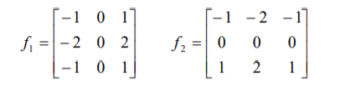

Figure 1: Sobel Gradient Kernels

The Sobel gradient output had to be normalized to a range of 0 – 255. This was done by finding the max and minimum values and rescaling to the 0 – 255 range. The next step was to normalize the energies in the 7x7 window to a range of 0 – 1. This was done in the same way that the Sobel Gradient image was normalized. Once all energies were normalized the total sum of the energies in the 7x7 window was obtained. Finally, the contour points were moved to the new location. To do this, the minimum energy value within the 7x7 widow was found and the contour point was moved to the new location. This process was repeated 30 times to ensure the best contour positions.

**Results/Conclusion:**

The first step was to draw the initial contours on the original image. Below is the original image and an image of the initial contours:

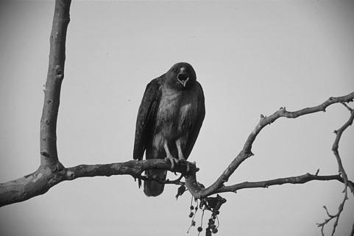

Figure 2: Original Image

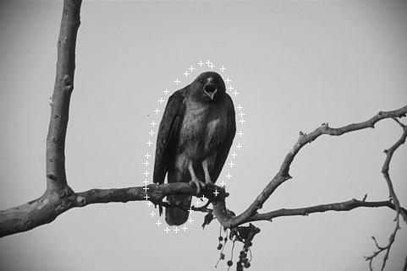

Figures 3: Initial Contours

The next step was to get the Sobel gradient to obtain better edges. The images below show the output of the Sobel gradient and its inverse:

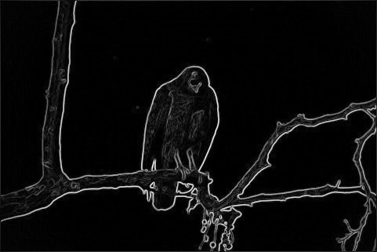

Figure 4: Sobel Gradient Output

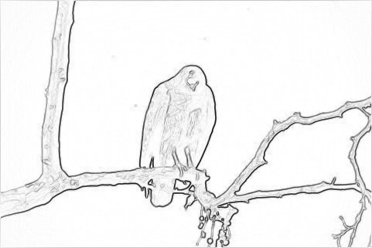

Figure 5: Inverted Sobel Gradient Output

Below is the original image with the final contour points plotted:

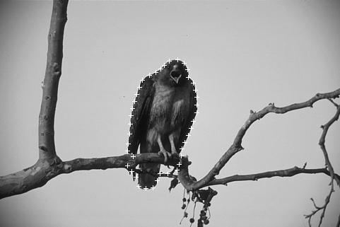

Figure 6: Final Output

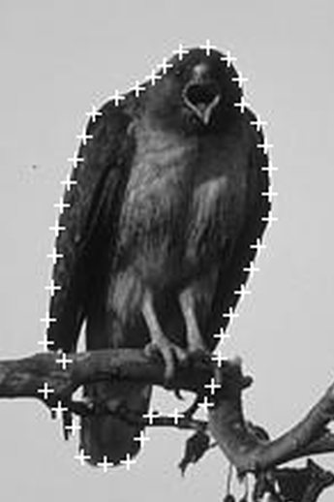

Figure 7: Final Contours

The final contour positions are able to detect the hawk successfully. Some of the points near the branches are not quite on the hawk but this is due to the gradient magnitudes of the branch. These could potentially be adjusted by weighing the internal and external energies a little differently. Weighing allows a certain energy to have more impact on the location of the contour points. In this case, internal energy two (the difference between the average distance and the distance between the current and next points) was amplified by doubling its magnitude when summing up the energies. Before this, some points were being pulled away from the hawk.

**Appendix A: New Contour Positions**

|  |  |
| --- | --- |
| COLS | ROWS |
| 265 | 98 |
| 266 | 109 |
| 273 | 117 |
| 276 | 127 |
| 278 | 137 |
| 278 | 148 |
| 278 | 159 |
| 273 | 171 |
| 270 | 181 |
| 266 | 191 |
| 261 | 201 |
| 257 | 210 |
| 256 | 220 |
| 253 | 232 |
| 250 | 240 |
| 237 | 245 |
| 226 | 245 |
| 222 | 255 |
| 216 | 265 |
| 206 | 266 |
| 196 | 263 |
| 192 | 250 |
| 186 | 242 |
| 180 | 234 |
| 188 | 221 |
| 180 | 213 |
| 181 | 203 |
| 183 | 189 |
| 184 | 175 |
| 185 | 163 |
| 187 | 153 |
| 190 | 143 |
| 193 | 133 |
| 197 | 123 |
| 201 | 113 |
| 211 | 106 |
| 220 | 102 |
| 227 | 97 |
| 232 | 92 |
| 239 | 86 |
| 251 | 84 |
| 260 | 89 |

**Source Code:**

#include <stdio.h>

#include <string.h>

#include <stdlib.h>

#include <math.h>

#define MAXRUNS 30

#define SQUARE(x) ((x) * (x))

//READ THE CONTENTS OF A GIVEN FILE

unsigned char *readImageData(FILE *inputImage, int inputR, int inputC)

{

unsigned char *returnFile;

returnFile = (unsigned char *)calloc(inputR * inputC, sizeof(unsigned char));

fread(returnFile, 1, inputR * inputC, inputImage);

fclose(inputImage);

return(returnFile);

}

// SOBEL GRADIENT

float *sobelGradient(unsigned char *inputImage, int ROW, int COL)

{

FILE *outputFile;

float *gradientImage;

int *convolutionImage;

unsigned char *normalizedImage;

int i, j, r, c;

int MIN = 0, MAX = 0, x, y, pos, pos1, pos2;

// KERNELS

int gx[9] = { -1, 0, 1, -2, 0, 2, -1, 0, 1 };

int gy[9] = { -1, -2, -1, 0, 0 , 0, 1, 2, 1 };

convolutionImage = (int *)calloc(ROW * COL, sizeof(int));

gradientImage = (float *)calloc(ROW * COL, sizeof(float));

for (i = 0; i < ROW * COL; i++)

{

convolutionImage[i] = inputImage[i];

}

for (r = 1; r < ROW - 1; r++)

{

for (c = 1; c < COL - 1; c++)

{

x = 0;

y = 0;

for (i = -1; i < 2; i++)

{

for (j = -1; j < 2; j++)

{

pos1 = ((r + i) * COL) + (c + j);

pos2 = (3 * (i + 1)) + (j + 1);

x += (inputImage[pos1] * gx[pos2]);

y += (inputImage[pos1] * gy[pos2]);

}

}

pos = (r * COL) + c;

convolutionImage[pos] = sqrt((x * x) + (y * y));

gradientImage[pos] = sqrt((x * x) + (y * y));

}

}

// FIND MAX AND MIN OF GRADIENT

MIN = convolutionImage[0];

MAX = convolutionImage[0];;

for (i = 1; i < ROW * COL; i++)

{

if (MIN > convolutionImage[i])

{

MIN = convolutionImage[i];

}

if (MAX < convolutionImage[i])

{

MAX = convolutionImage[i];

}

}

// NORMALIZE IMAGE

normalizedImage = (unsigned char *)calloc(ROW * COL, sizeof(unsigned char));

for (i = 0; i < ROW * COL; i++)

{

if (MIN == 0 && MAX == 0)

{

normalizedImage[i] = 0;

}

else

{

normalizedImage[i] = ((convolutionImage[i] - MIN) * (255 - 0) / (MAX - MIN)) + 0;

}

}

outputFile = fopen("sobel_output.ppm", "w");

fprintf(outputFile, "P5 %d %d 255\n", COL, ROW);

fwrite(normalizedImage, COL * ROW, 1, outputFile);

fclose(outputFile);

// INVERT IMAGE

for (i = 0; i < ROW * COL; i++)

{

normalizedImage[i] = 255 - normalizedImage[i];

}

outputFile = fopen("inverted_sobel_output.ppm", "w");

fprintf(outputFile, "P5 %d %d 255\n", COL, ROW);

fwrite(normalizedImage, COL * ROW, 1, outputFile);

fclose(outputFile);

free(normalizedImage);

free(convolutionImage);

return(gradientImage);

}

float *normalizeEnergy(float *originalData, int size, float newMin, float newMax, float min, float max)

{

float *normalizedOutput;

int i;

normalizedOutput = (float *)calloc(size * size, sizeof(float));

for (i = 0; i < size * size; i++)

{

normalizedOutput[i] = ((originalData[i] - min) * (newMax - newMin) / (max - min)) + newMin;

}

return(normalizedOutput);

}

// ACTIVE CONTOURS ALGORITHM

void activeContour(unsigned char *inputImage, float *sobelImage, int inputR, int inputC,int numContours, unsigned int **contours)

{

float *internalE1, *internalE2, *externalE, *totalE, *invertedSobel;

float MIN = 0, MAX = 0, minE;

float avgX, avgY, avgDistance;

int i, j, k, contourX, contourY, n;

int newContourPos[numContours][2];

int pos, pos2, row, col;

unsigned char *finalContoursImage;

int runCount;

float newMin = 0.0, newMax = 1.0;

//int debug = 0;

internalE1 = (float *)calloc(49, sizeof(float));

internalE2 = (float *)calloc(49, sizeof(float));

externalE = (float *)calloc(49, sizeof(float));

totalE = (float *)calloc(49, sizeof(float));

invertedSobel = (float *)calloc(inputC * inputR, sizeof(float));

finalContoursImage = (unsigned char *)calloc(inputC*inputR, sizeof(unsigned char));

// FIND MIN AND MAX OF SOBEL IMAGE

MIN = MAX = sobelImage[0];

for (i = 1; i < inputR - 1; i++)

{

for (j = 1; j < inputC - 1; j++)

{

pos = (i * inputC) + j;

if (MIN > sobelImage[pos])

{

MIN = sobelImage[pos];

}

if (MAX < sobelImage[pos])

{

MAX = sobelImage[pos];

}

}

}

// INVERT IMAGE

for (i = 0; i < inputC * inputR; i++)

{

invertedSobel[i] = (float)MAX - sobelImage[i];

}

// ENERGY CALCULATIONS

for (runCount = 0; runCount < MAXRUNS; runCount++)

{

avgX = avgY = avgDistance = 0.0;

// AVG DISTANCE BETWEEN POINTS

for (i = 0; i < numContours - 1; i++)

{

avgX = SQUARE(contours[i][0] - contours[i + 1][0]);

avgY = SQUARE(contours[i][1] - contours[i + 1][1]);

avgDistance += sqrt(avgX + avgY);

newContourPos[i][0] = 0;

newContourPos[i][1] = 0;

}

avgX = SQUARE(contours[i][0] - contours[0][0]);

avgY = SQUARE(contours[i][1] - contours[0][1]);

newContourPos[i][0] = 0;

newContourPos[i][1] = 0;

avgDistance += sqrt(avgX + avgY);

avgDistance = avgDistance / numContours;

for (i = 0; i < numContours; i++)

{

contourY = contours[i][0]; //col

contourX = contours[i][1]; //row

pos = 0;

for (j = contourX - 3; j <= contourX + 3; j++)

{

for (k = contourY - 3; k <= contourY + 3; k++)

{

if (i + 1 < numContours)

{

internalE1[pos] = SQUARE(k - contours[i + 1][0]) + SQUARE(j - contours[i + 1][1]);

internalE2[pos] = SQUARE(sqrt(internalE1[pos]) - avgDistance);

}

else

{

internalE1[pos] = SQUARE(k - contours[0][0]) + SQUARE(j - contours[0][1]);

internalE2[pos] = SQUARE(sqrt(internalE1[pos]) - avgDistance);

}

pos2 = (j * inputC) + k;

externalE[pos] = SQUARE(invertedSobel[pos2]);

pos++;

}

}

// MIN AND MAX OF ENERGIES

MIN = 0;

MAX = 0;

float *normInterE1, *normInterE2, *normExt;

MIN = MAX = internalE1[0];

for (n = 1; n < 49; n++)

{

MIN = fmin(MIN, internalE1[n]);

MAX = fmax(MAX, internalE1[n]);

}

normInterE1 = normalizeEnergy(internalE1, 7, newMin, newMax, MIN, MAX);

MIN = MAX = internalE2[0];

for (n = 1; n < 49; n++)

{

MIN = fmin(MIN, internalE2[n]);

MAX = fmax(MAX, internalE2[n]);

}

normInterE2 = normalizeEnergy(internalE2, 7, newMin, newMax, MIN, MAX);

MIN = MAX = externalE[0];

for (n = 1; n < 49; n++)

{

MIN = fmin(MIN, externalE[n]);

MAX = fmax(MAX, externalE[n]);

}

normExt = normalizeEnergy(externalE, 7, newMin, newMax, MIN, MAX);

// CALCULATE TOTAL ENERGY

for (j = 0; j < 49; j++)

{

totalE[j] = normInterE1[j] + 2 * normInterE2[j] + normExt[j];

}

// FIND MINIMUM ENERGY VALUE

minE = totalE[0];

pos = 0;

for (j = 0; j < 49; j++)

{

if (minE > totalE[j])

{

minE = totalE[j];

pos = j;

}

}

// DETERMINE NEW CONTOUR POINTS POSITIONS

pos2 = pos / 7;

if (pos2 < 3)

{

// new col = old row - abs(index - 3)

newContourPos[i][0] = contours[i][1] - abs(pos2 - 3);

}

else if(pos2 > 3)

{

newContourPos[i][0] = contours[i][1] + abs(pos2 - 3);

}

else

{

newContourPos[i][0] = contours[i][1];

}

pos2 = pos % 7;

if (pos2 < 3)

{

newContourPos[i][1] = contours[i][0] - abs(pos2 - 3);

}

else if (pos2 > 3)

{

newContourPos[i][1] = contours[i][0] + abs(pos2 - 3);

}

else

{

newContourPos[i][1] = contours[i][0];

}

}

// MOVE TO NEW POINTS

for (i = 0; i < numContours; i++)

{

contours[i][0] = newContourPos[i][1];

contours[i][1] = newContourPos[i][0];

}

}

int x, y;

// DRAW NW CONTOURS

for (i = 0; i < inputC * inputR; i++)

{

finalContoursImage[i] = inputImage[i];

}

for (i = 0; i < numContours; i++)

{

y = contours[i][0]; //Col

x = contours[i][1]; //Row

for (row = -3; row < 4; row++)

{

pos = ((x + row) * inputC) + y;

finalContoursImage[pos] = 255;

}

for (col = -3; col < 4; col++)

{

pos = (x * inputC) + (y + col);

finalContoursImage[pos] = 255;

}

}

// WRITE OUTPUT FILE

FILE *outputFile;

outputFile = fopen("finalContours.ppm", "w");

fprintf(outputFile, "P5 %d %d 255\n", inputC, inputR);

fwrite(finalContoursImage, inputC * inputR, 1, outputFile);

fclose(outputFile);

// CREATE FILE WITH FINAL CONTOUR POINTS

FILE *file;

file = fopen("contourPoints.csv", "w");

fprintf(file, "COLS,ROWS\n");

for (i = 0; i < numContours; i++)

{

fprintf(file, "%d,%d\n", contours[i][0],contours[i][1]);

}

fclose(file);

// FREE MEMORY

free(internalE1);

free(internalE2);

free(externalE);

free(totalE);

free(invertedSobel);

}

int main(int argc, char *argv[])

{

FILE *inputImage, *inputTextFile;

unsigned char *imageData;

unsigned int **contours;

int numContourPoints = 0;

int i;

char ch;

int inputMax, inputC, inputR;

char inputHeader[80];

unsigned char *initContoursImage;

float *gradientImage;

// CHECK USAGE

if (argc != 3)

{

printf("Usage: ./contours <input image> <initial contour file>\n");

exit(1);

}

// OPEN FILES

inputImage = fopen(argv[1], "r");

inputTextFile = fopen(argv[2], "r");

if (inputTextFile == NULL)

{

printf("ERROR: Could not open countours file\n");

exit(0);

}

if (inputImage == NULL)

{

printf("ERROR: Could not open input image\n");

exit(0);

}

// PARSE HEADER

fscanf(inputImage, "%s %d %d %d\n", inputHeader, &inputC, &inputR, &inputMax);

// READ IMAGE DATA

imageData = readImageData(inputImage, inputR, inputC);

// FIND HOW MANY CONTOUR POINTS ARE GIVEN

while (!feof(inputTextFile))

{

ch = fgetc(inputTextFile);

if (ch == '\n')

{

numContourPoints++;

}

}

numContourPoints++; // LAST LINE NOT COUNTED SINCE IT IS THE END OF FILE

rewind(inputTextFile);

// INITIALIZE ARRAY TO STORE INITIAL CONTOUR POINT COORDINATES

contours = (unsigned int **)calloc(numContourPoints, sizeof(unsigned int*));

for (i = 0; i < numContourPoints; i++)

{

contours[i] = (unsigned int *)calloc(2, sizeof(unsigned int));

}

// READ CONTOUR POINTS INTO ARRAY

for (i = 0; i < numContourPoints; i++)

{

fscanf(inputTextFile, "%d", &contours[i][0]);

fscanf(inputTextFile, "%d", &contours[i][1]);

//printf("%d %d\n", contours[i][0],contours[i][1]);

}

int x, y, pos, row, col;

// DRAW INITIAL CONTOUR LINE TO IMAGE

initContoursImage = (unsigned char *)calloc(inputC * inputR, sizeof(unsigned char));

for (i = 0; i < inputC * inputR; i++)

{

initContoursImage[i] = imageData[i];

}

for (i = 0; i < numContourPoints; i++)

{

y = contours[i][0]; //Col

x = contours[i][1]; //Row

for (row = -3; row < 4; row++)

{

pos = ((x + row) * inputC) + y;

initContoursImage[pos] = 255;

}

for (col = -3; col < 4; col++)

{

pos = (x * inputC) + (y + col);

initContoursImage[pos] = 255;

}

}

// WRITE OUTPUT FILE

FILE *outputFile;

outputFile = fopen("initialContours.ppm", "w");

fprintf(outputFile, "P5 %d %d 255\n", inputC, inputR);

fwrite(initContoursImage, inputC * inputR, 1, outputFile);

fclose(outputFile);

// CALCULATE SOBEL GRADIENT OF IMAGE

gradientImage = sobelGradient(imageData, inputR, inputC);

// RUN ACTIVE CONTOURS ALGORITHM

activeContour(imageData, gradientImage, inputR, inputC, numContourPoints, contours);

}